**Session: Control Flow and Built in Data Structures**

**Name: Ahan Jain**

**EmpID: 8202**

**1. Write a code to filter all sub-strings which has even number of vowel? example Input: "I have an input string which contains even and odd numbers of vowels aA aa aaa ae aeo” output: I an string which contains and odd of aaa aeo**

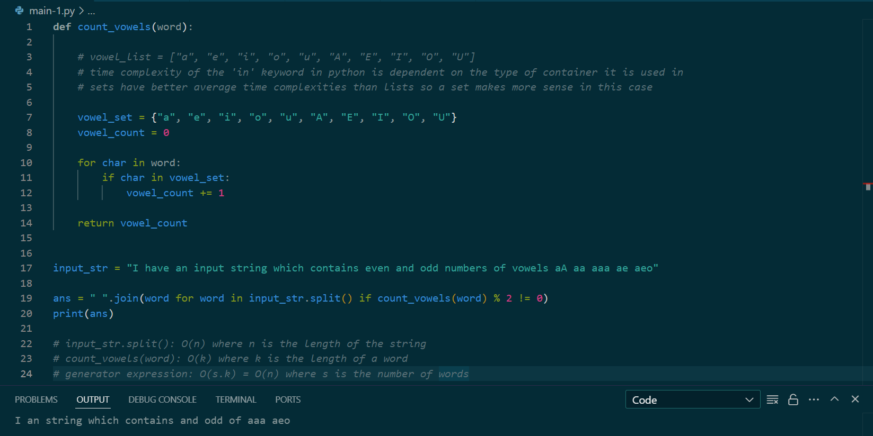

**2. Programing: From a multi-words and multi-line string, prepare a dict with key as "word" and value as occurrence of word. Example Input: astring = """Python Multiline String Using Triple-Quotes Using the triple quotes style is one of the easiest and most common ways to split a large string into a multiline Python string. Triple quotes (''' or \""") can be used to create a multiline string. It allows you to format text over many lines and include line breaks. Put two triple quotes around the multiline Python string, one at the start and one at the end, to define it.""" output (Partical): {'the': 5, 'to': 4, 'Python': 3, 'quotes': 3, 'one': 3, 'and': 3, 'a': 3, 'multiline': 3, 'Using': 2, 'triple': 2, 'string.': 2, 'at': 2, 'Multiline': 1, 'String': 1, 'Triple-Quotes': 1, 'style': 1, 'is': 1, 'of': 1, 'easiest': 1, 'most': 1, 'common': 1, 'ways': 1, 'split': 1, 'large': 1, 'string': 1, 'into': 1, 'Triple': 1, "('''": 1, 'or': 1, '""")': 1, 'can': 1, 'be': 1, 'used': 1, 'create': 1, 'It': 1, 'allows': 1, 'you': 1, 'format': 1, 'text': 1, 'over': 1, 'many': 1, 'lines': 1, 'include': 1, 'line': 1, 'breaks.': 1, 'Put': 1, 'two': 1, 'around': 1, 'string,': 1, 'start': 1, 'end,': 1, 'define': 1, 'it.': 1}**

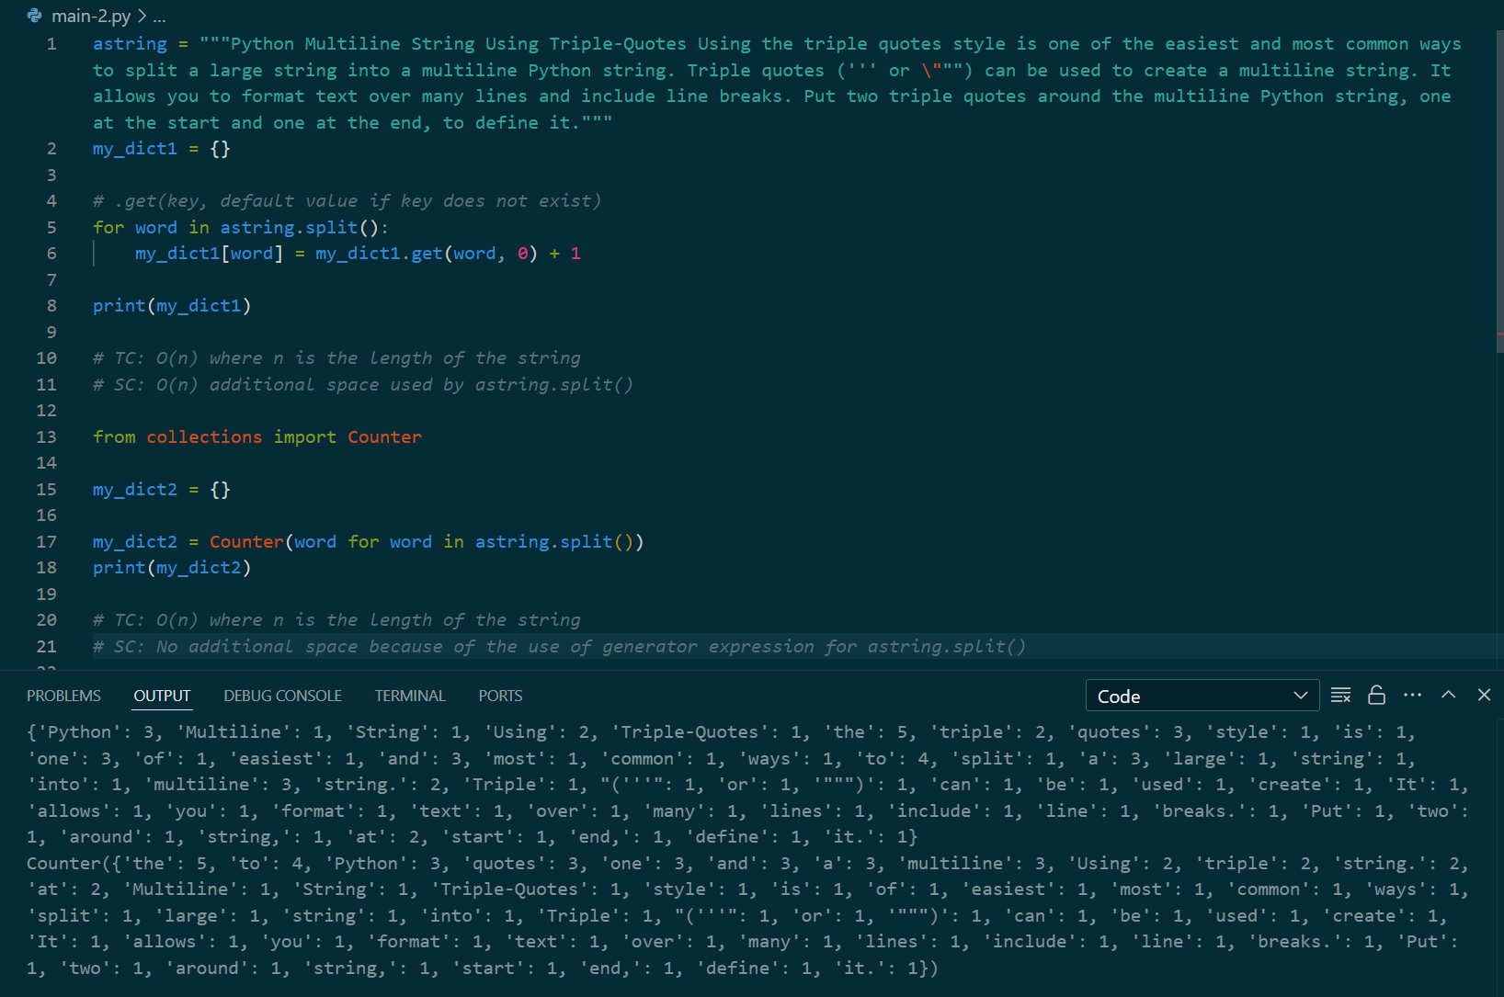

**3. Programing: From a multi-words and multi-line string, prepare a filter the list of words which have multiple occurrences in the string. Example Input: astring = """Python Multiline String Using Triple-Quotes Using the triple quotes style is one of the easiest and most common ways to split a large string into a multiline Python string. Triple quotes (''' or \""") can be used to create a multiline string. It allows you to format text over many lines and include line breaks. Put two triple quotes around the multiline Python string, one at the start and one at the end, to define it.""" output: Python Using the triple quotes one and to a multiline string at.**

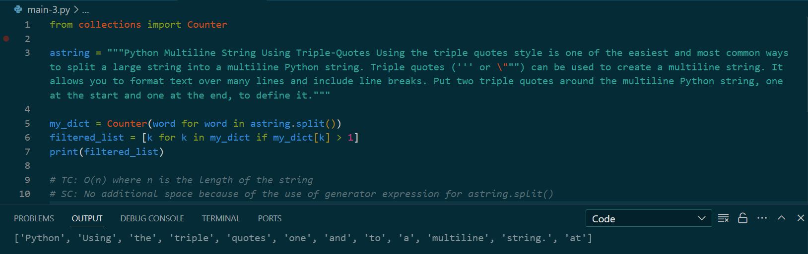

**4. Programing: From a multi-words and multi-line string, display list of words and word's length with occurrence more than 1 in sorted order Example Input: astring = """Python Multiline String Using Triple-Quotes Using the triple quotes style is one of the easiest and most common ways to split a large string into a multiline Python string. Triple quotes (''' or \""") can be used to create a multiline string. It allows you to format text over many lines and include line breaks. Put two triple quotes around the multiline Python string, one at the start and one at the end, to define it.""" Word Length Occurrence Python 6 3 Using 5 2 the 3 5 triple 6 2 quotes 6 3 one 3 3 and 3 3 to 2 4 a 1 3 multiline 9 3 string. 7 2 at 2 2**

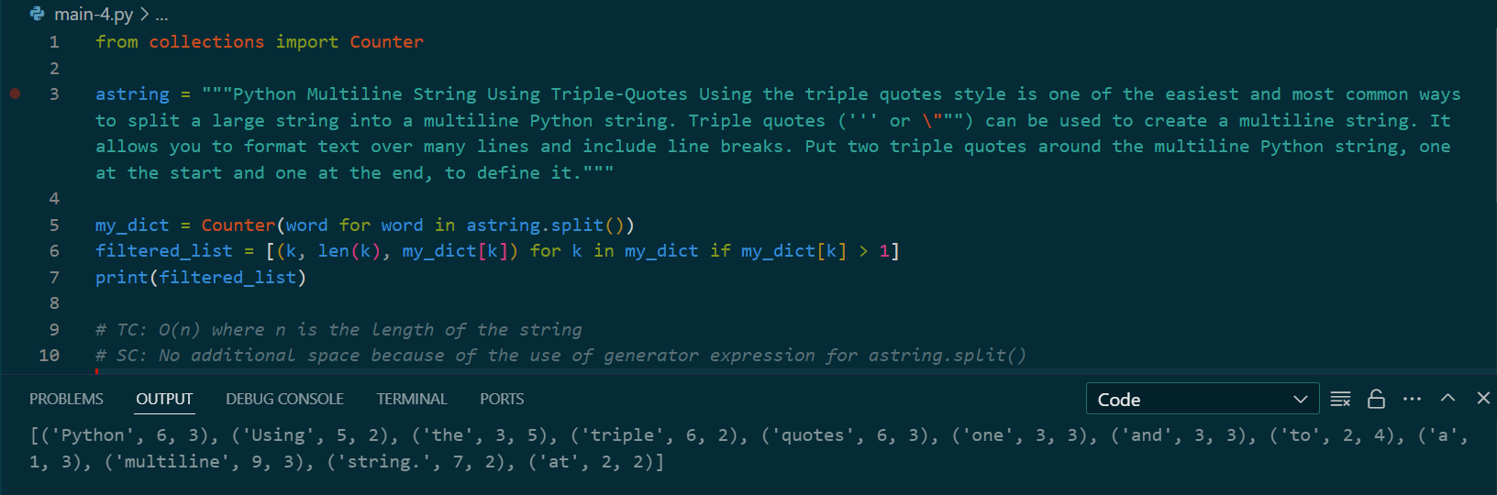

**5. Print the first n primes**

